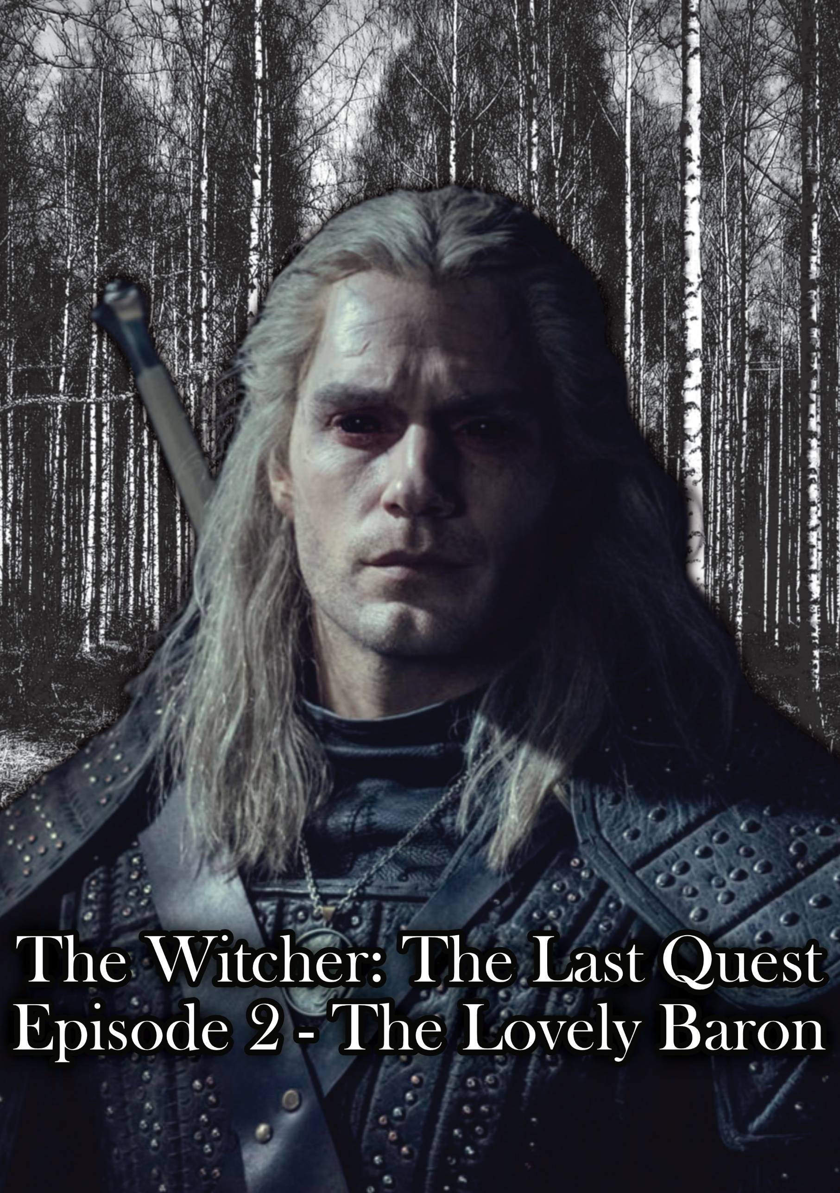

EPISODE 2 – The Lovely Baron

The screen fades into Geralt and the Baron sitting and drinking in his office room playing cards. Geralt places down a monster card and 2 more cards move into position, floating out of the deck. The monsters appear of the card and screech at the Baron’s siege stack. A cigar is lit but sitting in an ash tray slowly smoking, the whisps of smoke flicking up into the air as if dancing, the subtle warm fire from a fireplace lights the room. The Baron picks up his cigar and puffs and then says:

“So, what do I call you?”

Geralt watches him in a silent stew and then says:

“Geralt, of Rivia.”

The baron puffs hard as if thinking, breaths out of his nose and says:

“I’ve never been… to Rivia I mean.”

Geralt smiles slightly and says:

“It’s not as beautiful as it sounds.”

The baron smiles a sly and somewhat evil smile and says:

“I think that’s true of the entire continent.”

He places down a second ballista and it folds out of the paper. Geralt says:

“Stacking siege cards?”

The Baron smiles and says:

“Well, it is one strategy, I got dealt a terrible hand.”

Geralt smiles and places down an impenetrable fog card, the fog appears over the Baron’s archers. The Baron smiles and places down a clear weather card and the fog dissipates, as a small sun appears over the game and says:

“Witcher, you can’t beat a full stack of catapults with that.”

The Witcher watching him, no emotion present and places down a torrential rain card, a dark nimbus cloud appears of the siege stack, and it starts storming, the ballistas lock up and become rusty, the Baron’s face turns dark as Geralt says:

“You were saying something…”

The baron punches the table, Geralt’s eyes dart to his first as he shouts:

“Damn torrential rain!”

Geralt sits back and takes a sip of his drink, the Baron hands him a Shani card and says:

“Just take it. I want a rematch though.”

Geralt smiles, takes the card and says:

“So, tell me about your wife, did she have any other lovers, friends, cousins where she’d go?”

The Baron’s look turns stern as he says:

“Are you implying my wife was unfaithful?”

Geralt sips his drink and says softly:

“Anything is possible.”

The Baron’s jaw tightens and he says:

“No, she didn’t. At least to my knowledge. Her family is mostly dead, though she does have a sister.”

Geralt grunts and then says:

“Is it possible she was murdered by one of the locals, or kidnapped?”

The Baron sits back puffing on his cigar and says:

“We haven’t received ransom terms. Her room is upstairs if you think you’ll find any clues.”

Geralt stands and the Baron then says as he stands too:

“If it’s murder that’s a different punishment entirely…”

Geralt pauses as the Baron leads the way and says:

“I guess the nickname’s fitting.”

We smash cut to:

***TITLE SCREEN:  
THE WITCHER – Episode 02: The Lovely Baron***

We fade into The Baron walking out of the room. Geralt follows the Baron as the screech of the wooden boards fills the air, screaming out as if in pain, a red figment, a scent appears as he walks up the stairs. The Baron signals to the room and says:

“This is our room.”

Geralt walks in, there’s dust filling the air, a table has been flipped over, a curtain is half torn off the railing, we slowly walk in as the boards creak, running a finger across a wooden make up table. His finger stops on a blood stain in the wood, the red scent mist from before leads to a small perfume bottle. Geralt picks it up and looks at the label and says:

“Lavendar…”

He takes a sniff of the bottle and says:

“Interesting, homemade.”

He places it down and the environment goes black and white as a deep synth drone ripples through the screen, red figures arguing and fighting in the room. Geralt emotionless walks through the different events. A fat red figure throws a candle stick holder at his head, and he doesn’t move. It travels through his head and smashes onto the ground. The candle stick holder is still there. Geralt says under his breath:

“Definitely ran…”

He sees a red figure leave the room with a bag and follows it as it enters the Baron’s daughter’s room. One of the red figures wakes up the other and they leave. Geralt says under his breath again:

“And she took the daughter with her.”

We see the red figures run out of the room together and Geralt walks out. The world fades back in and the Baron says:

“You find anything interesting?”

Geralt walks down the stairs following a new trail and says:

“Perhaps.”

The baron follows him as he walks down and down a hallway. He sees the glinting of a piece of jewelry stuck in the floorboards. He kneels and picks it out of the floorboards and asks:

“Do you know what this is?”

The Baron says:

“I’ve never seen it before.”

Geralt looks at it intently, the light shimmering off the necklace and the Baron cuts in and says:

“There might be someone who knows though…”

Geralt stands and raises an eyebrow as the Baron says:

“There’s a Pellar, who lives in a hut in the woods. Just be gentle he’s a little… different.”

Geralt puts the pendant in his pocket, he pauses for a second, then looks at the Baron dead in the eyes and says:

“I *know* how to be gentle.”

He turns to leave, the Baron’s face angry but controlled watches him leave, his jaw tightens, as the door slams. We cut outside, Geralt takes a breath and Geralt starts to walk down to Love in Portofino by Dalida, it’s now sunset, raining lightly, a lightning storm brewing in the distance. Geralt puts on his hood and leaves the gates of the Baron’s keep. He walks down the streets alone, the sounds of the villagers closing for the night. As the the song’s Chorus ends it cuts temporarily, as Geralt hears 2 old women speaking on a porch:

Woman 1: “Did you hear that there’s been sightings of a witch?”

Woman 2: “A witch in Velen? Why would they come here of all places?”

Woman 1: “She’s been healing some of the locals of plague.”

Woman 2: “Witches bring nothing but death and destruction.”

Woman 1: “And controlling half the north.”

Woman 2: “The eternal fire will cleanse the world.”

Woman 1 (smiling): “I couldn’t have said it better myself.”

The Witcher mutters under his breath as he leaves:

“A witch healing people?”

He walks past the tavern from episode 1 as the song fades back in, and Roach notices him and follows him, they leave the village and pass the guards on their way out. Geralt turns to Roach and says:

“What do you think?”

Roach huffs at him and he smiles and says:

“Exactly what I was thinking.”

He jumps onto Roach, and they gallop past the guards as the song ends.   
  
We fade to Geralt and Roach on the road slowly now, Geralt watches the woods. The sounds of the environment drop. Only the sound of his breath can be heard, the hoof beats on the stones of the road echoing in the darkness. The sun still brightly lights the road although it’s dusk it does not the swamp. Roach slows to a stop. Geralt looks left, as the camera follows him, and then right. 2 red eyes glow in the black void of the forest, a horror synth plays in the background, a rumbling bass as the eyes grow in brightness. Geralt puts his hand on the handle of his blade. The eyes follow his hand, Geralt stares into the eyes as they flip back to his face, studying him. A low growl can be heard, and Geralt grips the blade. The eyes retreat into the woods and disappear. Geralt sighs and says to Roach:

“I guess even the trees are watching us now…”

Roach huffs in agreement and continues to trot. Geralt still prepared to draw, watching the same spot in the forest. We use his face to fade transition to them arriving at a hut in the woods, 3 men stand outside of his door.   
  
Man 1 (Banging on the door violently): “PELLAR! GET OUT HERE!”

Man 2 (leaning against the fence): “He’s not coming out.”

Man 3 (lighting a torch): “Then we’ll cleanse this place with him in it!”

Geralt clears his throat and says:

“You wouldn’t happen to know where the Pellar is?”

The three men turn around…  
  
Man 3: “A mutant?!”

Man 1 (Unsheathing his blade): “Get out of here!”

Geralt unsheathes his blade and says under his breath:

“Maybe we are the real monsters…”

The first man lunges at him, Geralt dodges and decapitates the man. The torch falls to the ground and starts lighting the floor on fire. The second man shouts and runs towards him, Geralt swings cutting his weak steel sword in half and his body falls into 2 pieces. The man at the door turns around and runs towards him with his sword out, Geralt uses Igni lighting the man on fire and he runs into the field screaming and collapses. Roach looks at the man, Geralt says to Roach:

“You can’t disapprove you’re a horse.”

He sheathes his blade and walks up to the door and says:

“Pellar? You’re safe. The Baron sent me.”

The door opens and a skinny wiry man opens the door with a necklace of chicken, eel, and newt body parts strung around his neck. The pellar speaks:

“The pellar thanks the Witcher.”

Geralt pauses, taking out the necklace he found in the Baron’s keep and says:

“Did you make this?”

The pellar looks at it and picks it up. He says:

“The pellar made the necklace for Anna.”

Geralt says:

“Do you know where she is? She’s missing.”

The Pellar says:

“The pellar does not know, the pellar was waiting for the witcher.”

Geralt looks around and says:

“What happened between the Baron and Anna?”

The pellar closes off his body language, looks out to the garden and says:

“The Pellar won’t say. The pellar needs the Witcher to find Princess.”

Geralt sighs and says:

“There’s a princess now?”

The Pellar hands him a bell and says:

“The princess comes to the sound of the bell.”

He slams the door, and Geralt says under his breath:

“Yeah, the pellar will help me…”

He walks around the house and shakes the bell and calls out:

“Princess? Princess, come here.”

He looks out into the woods, now pitch black and takes a deep breath.

“What am I doing…”

He takes out his blade and starts to walk into the woods shaking the bell. The faint purple glow of the sword light just his face and arms as he walks into the pitch-black darkness of the forest. The silence is oppressive, crushing. A twig snaps behind Geralt, and he turns suddenly; he rings the bell in a fighting stance waiting for something to jump at him. More twigs snap around him; he places the bell on the ground and reaches for a Witcher formula (Cat). He takes a sip, and the void absorbs his eyes, almost ripping through his skull. The veins on his face become more pronounced and the world inverts in color, the black void of the forest becomes white, and black figures move around circling him on all 4s, a pack of wolves. One lowers and jumps at him; Geralt slashes the wolf and spray of pitch-black blood spills into the void. Another jumps, Geralt rolls forward beside it, sticking the third with his blade as the second lands missing him. Geralt stands, and slashes his blade to his side clearing it, looking to his side as the second regains its footing and runs to attack him, Geralt decapitates it and its body falls with the momentum it had. The final wolf looks at him growling. Geralt stands still, watching it his voice comes in, distorted, violent…

“Sit.”

The wolf stops growling and sits and whines. Geralt walks over to the bell and picks it up. He turns to the wolf and says:

“Run.”

The wolf runs off whining. Geralt takes a deep breath and continues his walk through the white void. He shakes the bell and sees ripples of sound waves in black spread out from it. Another twig snaps behind him. He sighs and says:

“Not again…”

He turns to see a goat, eating at the grass. He looks confused and rings the bell. The goat’s ears pick up, and it walks towards him. He says under his breath:

“So, you’re princess then?”

The goat knocks on the bell with its head and its head tilts as it rings. Geralt says under his breath:

“Let’s go.”

He starts walking back and ringing the bell as the goat follows. We cut to Roach eating the hay inside princess’ pen, outside the Pellar’s hut. The pellar comes out saying:

“No No No, the horse cannot eat princess’ food.”

Roach looks up at him chewing slowly. The pellar stops and says:

“The pellar will not allow it.”

Roach looks back down and starts eating the hay again and the Pellar sighs as Geralt comes from the back of the hut. Princess following him. The pellar reacts in pure joy and runs over saying:

“The Princess! She’s alive!”

Geralt says:

“You could’ve told me princess was a goat.”

The pellar hugs princess and starts to ring the bell as he says:

“Why would that have helped the witcher?”

Geralt sighs as the goat follows him into its pen and he closes the door. The pellar then says:

“The pellar will now reveal the truth to the witcher.”

Geralt raises an eyebrow and watches as the pellar shuffles into his hut. He follows him in, and the Pellar starts washing his hands. The walls have different animal carcasses hanging on them drying. Geralt looks around and says:

“Wonderful place...”

The pellar says:

“Anna had a child. The Baron attacked Anna, and the child died inside her.”

Geralt says:

“A miscarriage?”

The pellar says:

“The pellar tried to heal the child, but it was impossible.”

Geralt sighs and says:

“And the child never received a proper burial… a botchling.”

The Pellar says as he walks over to a table and starts dissecting a frog:

“The pellar sent Anna to the witch to be healed.”

Geralt says:

“The witch?”

The Pellar says:

“The witch helped Anna heal, but after the Baron and Anna could not live with his choices… like the Witcher can’t.”

Geralt’s eyes squint slightly and he says:

“And how do you know that?”

The Pellar says pointing at him:

“The Pellar sees all.”

Geralt pauses for a second looking at the amulet and says:

“You made this to protect her from him?”

The pellar says:

“The Pellar tried his best.”

Geralt starts to leave and the pellar says:

“The pellar sees the witcher… consumed by smoke and covered in blood.”

Geralt looks at his clothes and says:

“I do need a bath…”

The pellar says:

“The Witcher’s final quest… the search for the girl.”

Geralt’s eyes squint subtly and he leaves. As he exits, he walks over to Roach, Princess is mad at the fact he’s eating her food. Geralt whistles and says:

“Roach, we have to see a witch.”

Roach walks up to him and follows him as they walk down the road, lit only by the moon above, we sit for a second as eyes appear in the forest around them and the camera zooms out. Smash cut to credits.  
  
Similar kind of music vibe for the final credits, thought after the melancholy nature of the first episode there are 2 options I think would work:

* A standardized “theme song” written for the show in the spirit of the melancholy vibes.
* Clint Eastwood by Gorillaz would work here.
* Reminiscencias by Claudio Constantini would also work.
* A vibe switch. It could hit harder for this episode to be the real “Start of the journey/investigation and thus ending on a “country” type song written in universe might work better to juxtapose and leave those darker moments for more intense episodes.

*Author’s Note:*

*The characters and world of The Witcher belong to Andrzej Sapkowski and CD Projekt Red. This script, the dialogue, story flow, and narrative choices, or anything that is my original work is protected under Australian copyright law (registration pending). It is not intended for commercial use. Any use of this material without permission is prohibited, though reaction videos, breakdowns, and discussions are welcome and permitted in the spirit of collaboration. Additionally, artwork based on this is allowed, however I cannot guarantee, authorize or otherwise state that the shareholders will feel the same.*

END OF EPISODE